1. Find all books whose author is Faisal Abid and display name of book authors and

Categories

--- > db.book.find({authors:{$in:['Faisal Abid']}},{authors:1,category:1})

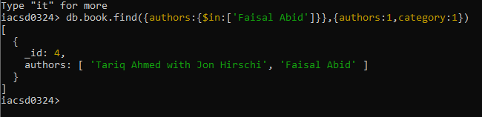

2. List all the books with category Internet at first position in category array

-- > db.book.find({'categories.0':{$in:['Internet']}})

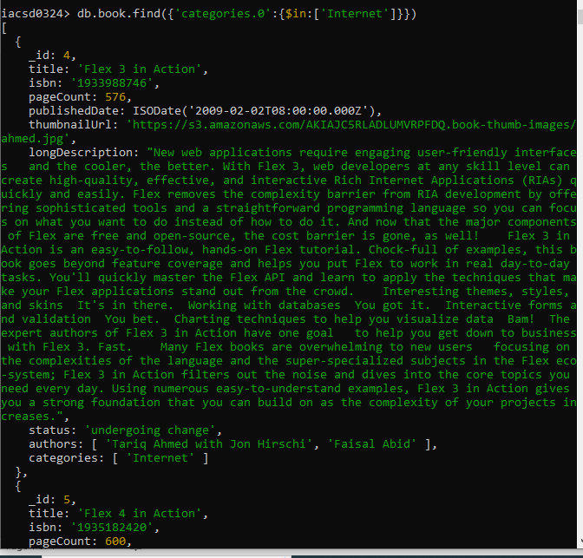

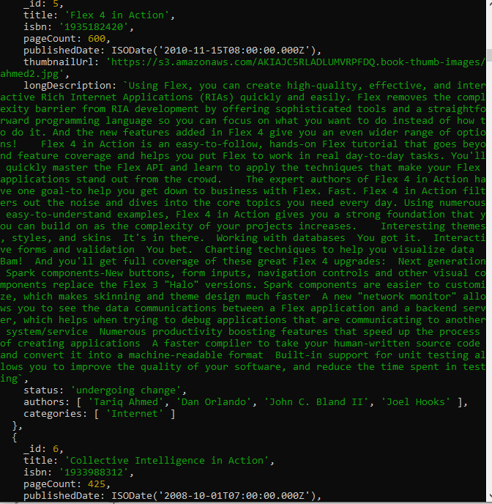

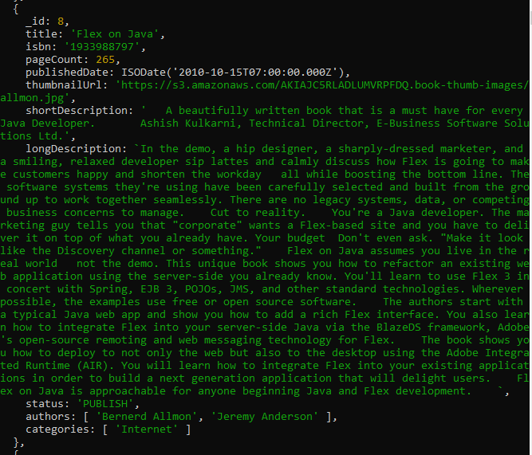

3. Change the status of books “undergoing change” for books having more than 500

pages and published in 2009

--- > b.book.updateMany({$and:[{pageCount:{$gt:500}},{$expr:{$eq:[{$year:'$publishedDate'} ,2009]}}]}, {$set:{status:'Undergoing changes'}});

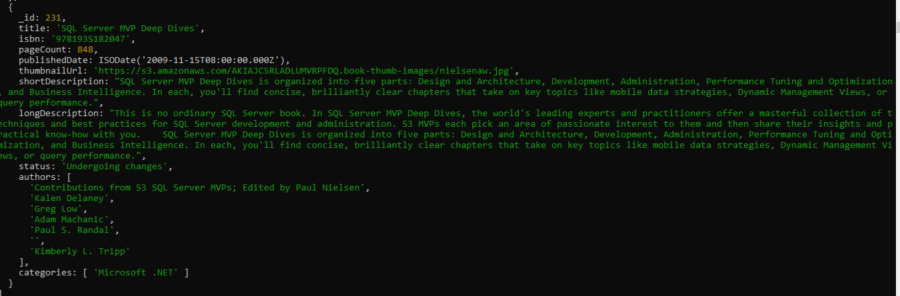

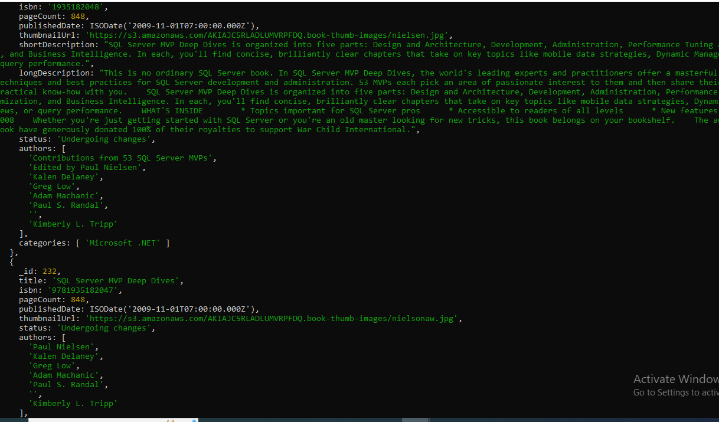

Find all the books containing word highlighting and depth in long description of the

Book

--- > db.book.find({$or:[{longDescription:{$regex:'highlighting'}},{longDescription:{$regex:'depth'}}]})

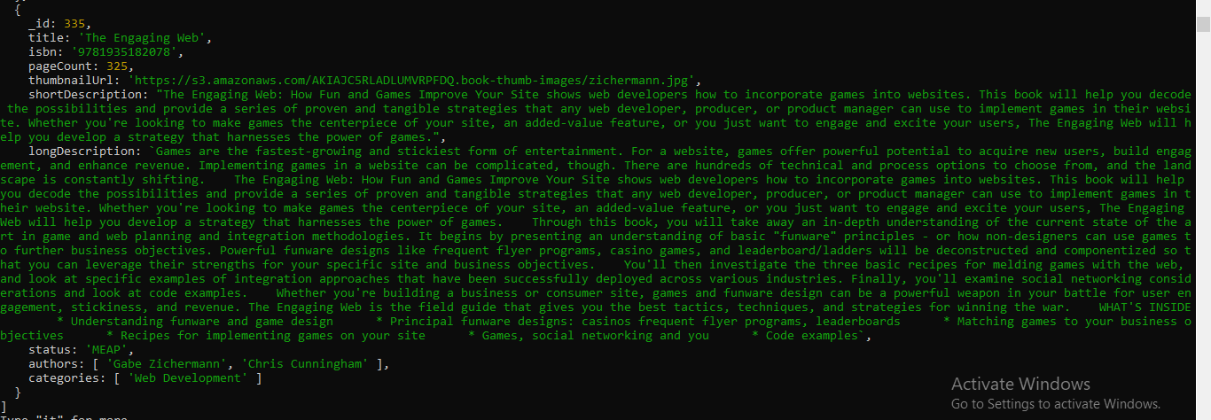

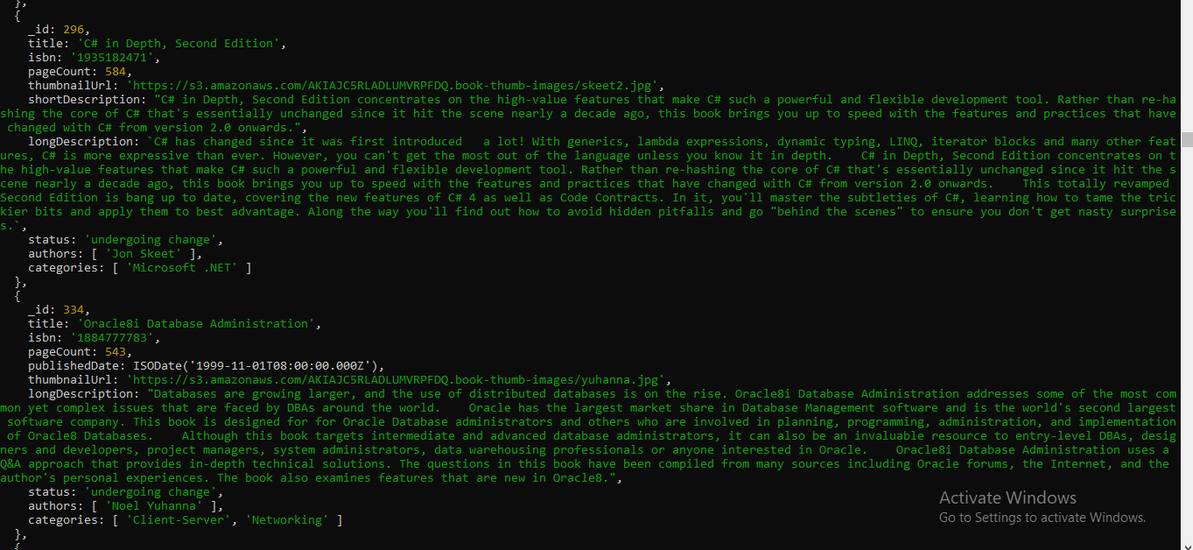

5. Display all books published in 2009

--- > db.book.find({$expr:{$eq:[{$year:'$publishedDate'} ,2009]}});

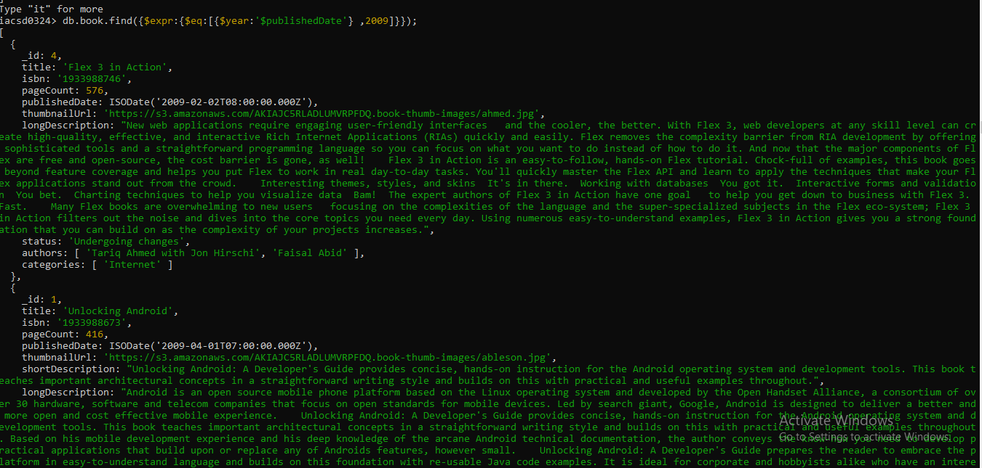

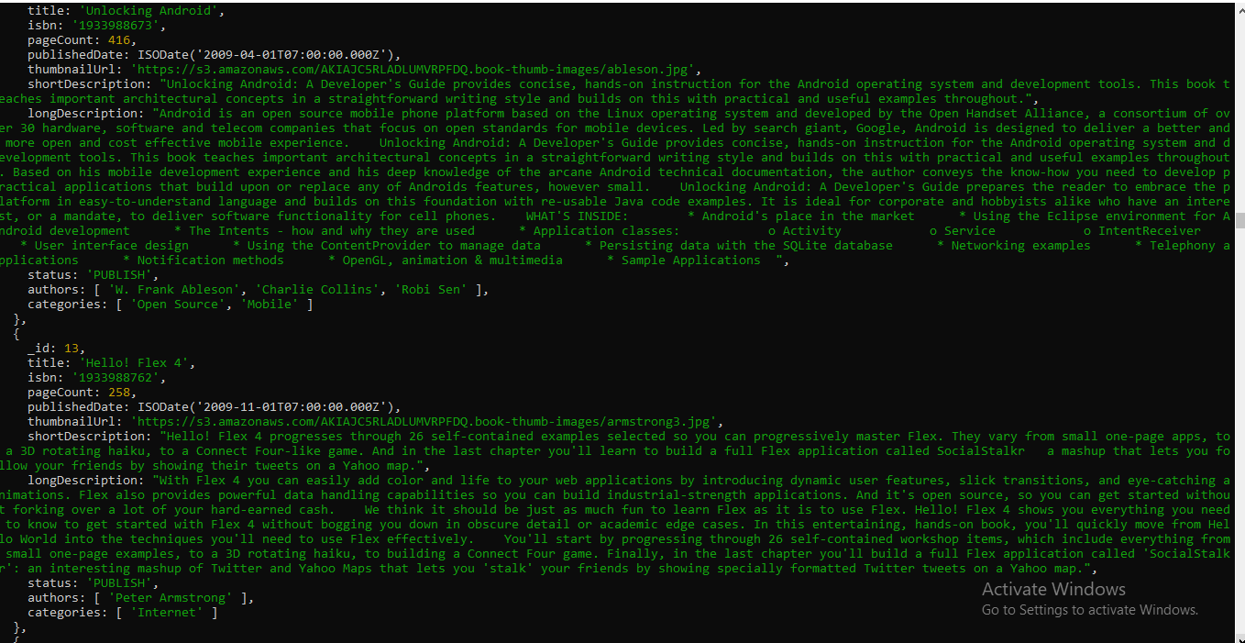

6. Find all books with pageCount is either 500 or 556 or 670

---- > db.book.find({pageCount:{$in:[500,560,600]}});

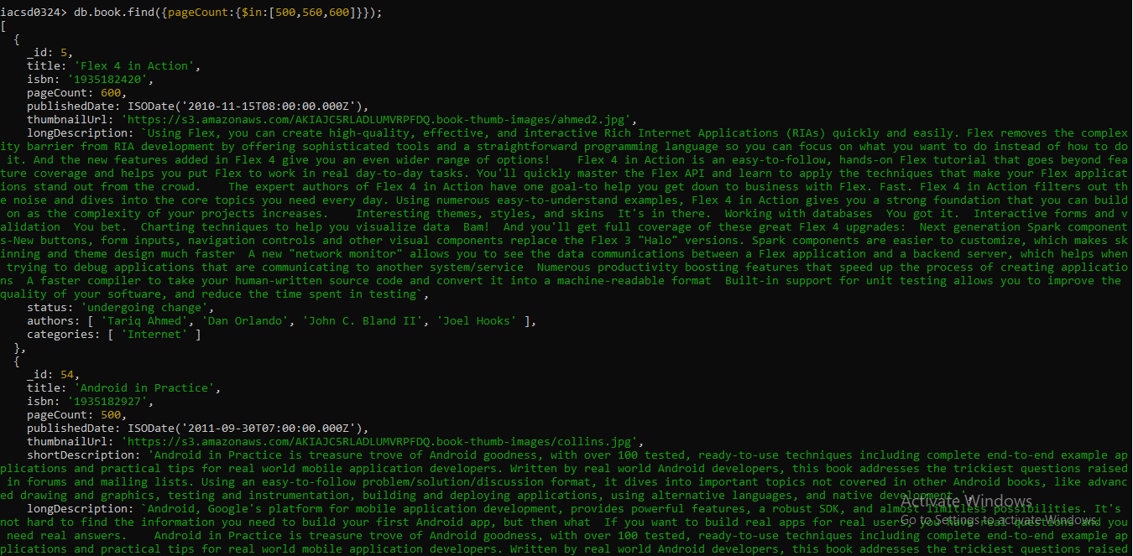

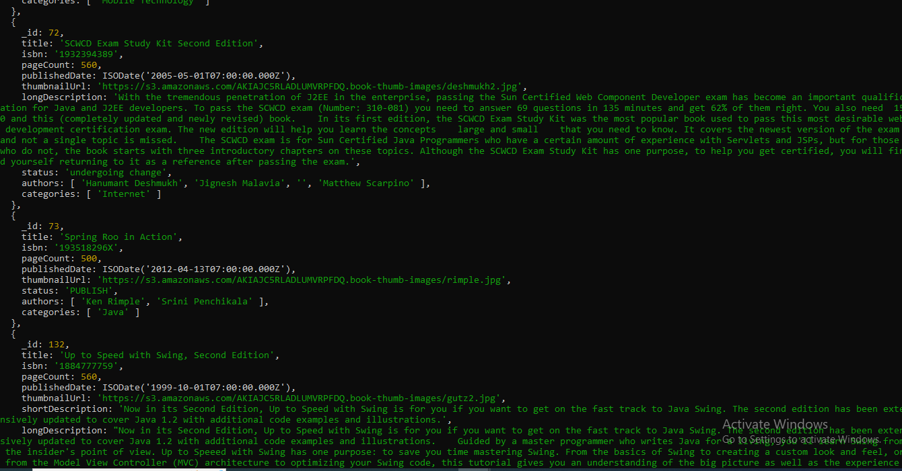

7. Add 2 categories “kindle” and “hard bind” in all the books if its pageCount >200 and

< 500 or number of pages >500